ASSIGNMENT 2
Write the SELECT queries to do the following:
1. Write a query that produces all rows from the Customers
table for which the salesperson’s number is 1001.
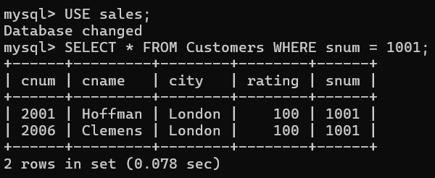

2. Write a select command that produces the rating followed
by the name of each customer in San Jose.
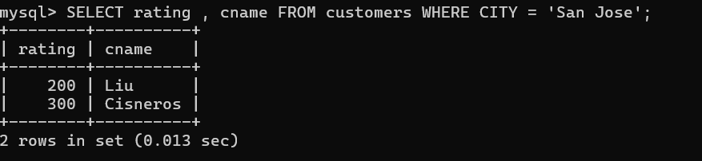

3. Write a query that will produce the snum values of all
salespeople from the Orders table (with the duplicate values
suppressed).
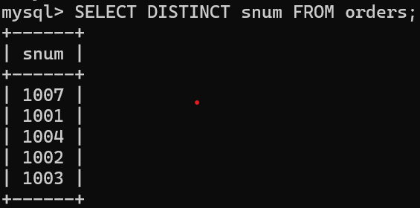

4. Write a query that will display all the orders for amount
more than Rs. 1,000.
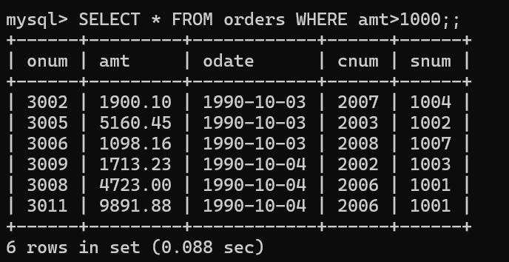
5. Write a query that will give you the names and cities of
all salespeople in London with a commission above 0.10.
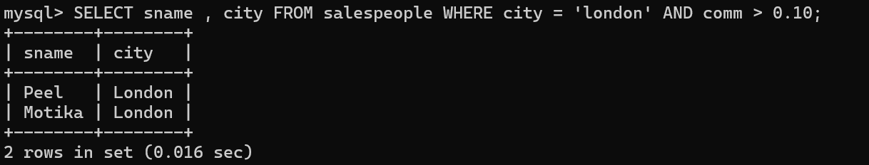
6. Write an SQL query that returns all customers who have a
rating greater than 100, along with the customers located in
Rome regardless of their rating.
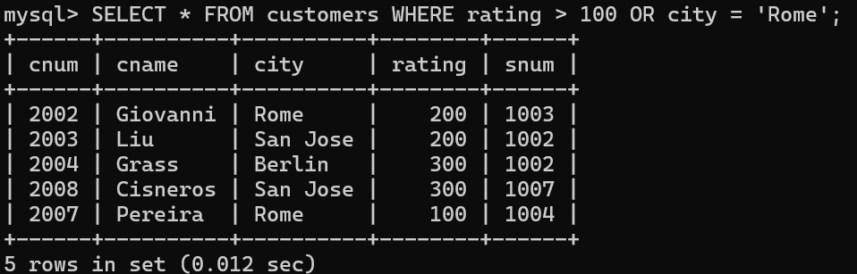

7. What will be the output from the following query?
Select * from Orders where (amt < 1000 OR NOT (odate = ‘1990-10-
03’ AND cnum > 2003));
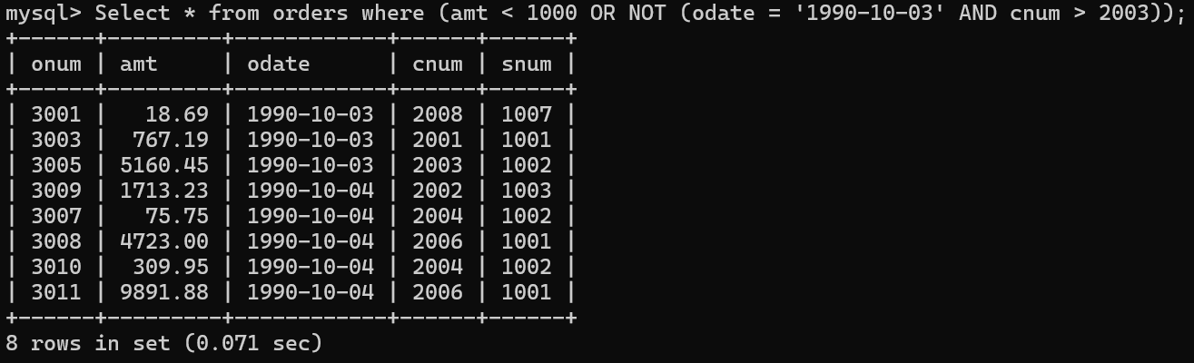
8. What will be the output of the following query?
Select * from Orders where NOT (odate = ‘1990-10-03’ OR snum
>1006) AND amt >= 1500;
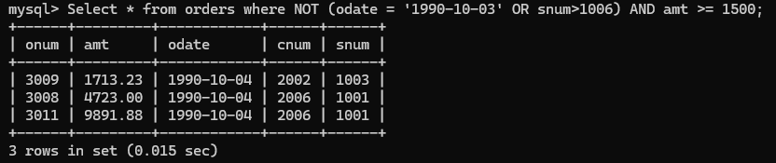
9. What is a simpler way to write this query?
Select snum, sname, city, comm from Salespeople
Where (comm >= .12 AND comm <= .14);
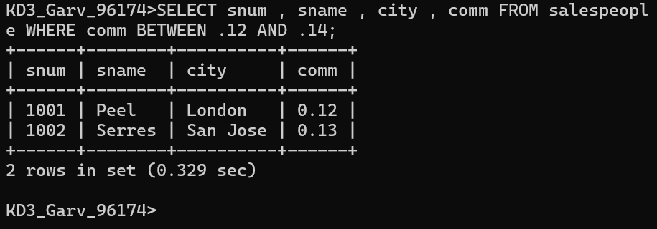
10. Write a query that selects all orders except those with amount less than 100. 